**TECHNICAL REPORT ON PROJECT 4.**

**BY**

**ADEGOKE BLESSING TUNMISE**

**VEPH/20B/DA189**

**Task 16B (iv)**

**ZOE & JOY GROUP OF COMPANY SALES PERFORMANCE ANALYSIS**

OUTLINE

1.     Introduction

2.     Story of Data

3.     Data Splitting

4.     Pre-Analysis

5.     In-Analysis and Insights

6.     Data Visualization

7.     Recommendations and Observations

8.     Conclusion

### ****1. Introduction****

This report presents an in-depth analysis of ZOE & JOY group of company sales performance, identifying key revenue drivers and trends that can enhance business operations and profitability in future financial years.

**2. Story of the data**

The dataset contains detailed records of sales transactions, including order details, product categories, revenue, customer demographics, and geographic information. The primary objective of this analysis is to determine trends in product performance, sales distribution, and customer engagement.

**Data Structure:**

* **Rows:** Represent individual sales transactions
* **Columns:** Include attributes such as Order Number, Product Line, Sales, Country, Month, Year, and Customer Name.

**3. Data Splitting**

**Independent Variables:**

* Product Line, Country, Customer Name, Order Date, Payment Method.

**Dependent Variables:**

* Sales Revenue, Quantity Ordered, Unit Price.

**4. Pre-Analysis and Intended Insights**

The analysis aims to answer the following key questions:

* What is the best-performing product category?
* Which country generates the highest revenue?
* Which month and year had the highest sales?
* Who are the top customers contributing to revenue?

**5. In-Analysis and Insights**

1. **Best Sales Year:**
   * 2004 recorded the highest total revenue of **$4,724,162.60**, followed by 2003.
2. **Top Sales Month:**
   * November generated the highest revenue of **$2,118,885.67**, followed by October.
3. **Best Performing Product Category:**
   * **Classic Cars** contributed the most revenue (**$3,919,615.66**), followed by **Vintage Cars**.
4. **Top Revenue-Generating Countries:**
   * **USA** had the highest revenue (**$3,627,982.83**), followed by Spain and France.
5. **Most Valuable Customers:**
   * **Euro Shopping Channel** made the most purchases (9,327 orders), followed by **Mini Gifts Distributors Ltd.**
   1. **Data Visualization**

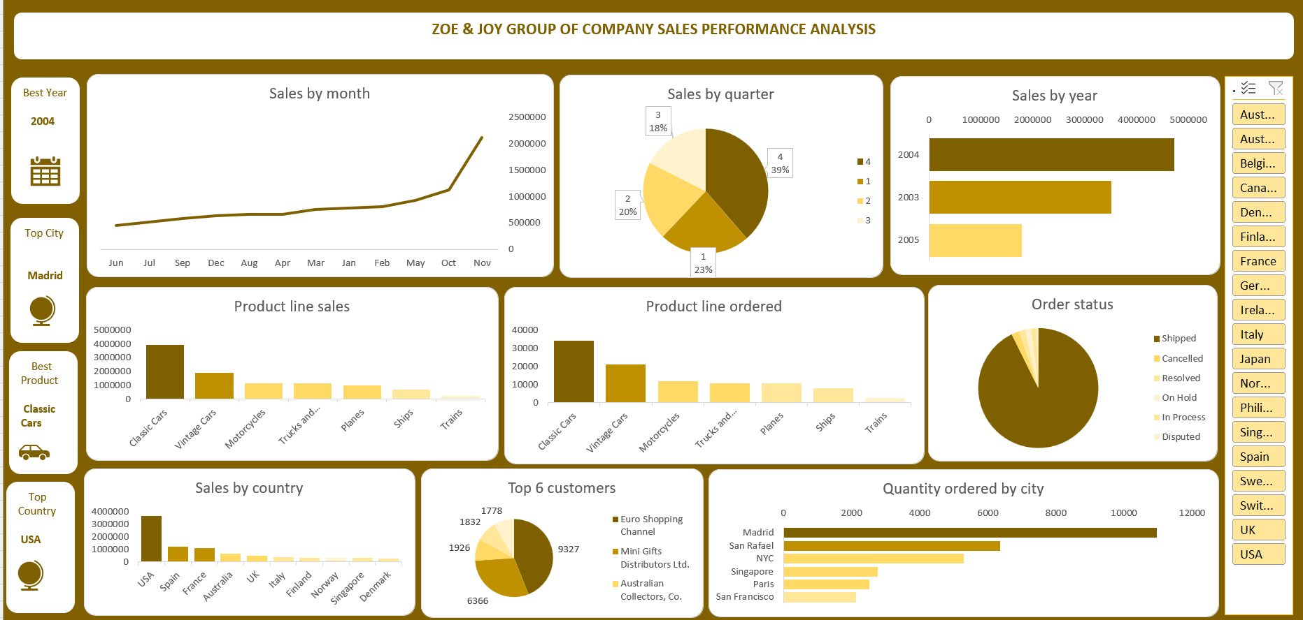

**7. Recommendations**

1. **Increase Market Penetration in Spain and France**
   * Sales are strong in the USA, but focusing on Spain and France with targeted promotions could boost international revenue.
2. **Expand Classic and Vintage Car Promotions**
   * These product lines contribute the most revenue; increasing stock availability and promotions could enhance sales.
3. **Customer Loyalty Programs**
   * Offering exclusive deals or loyalty rewards for top customers like **Euro Shopping Channel** can improve retention and long-term revenue.
4. **Seasonal Sales Strategy**
   * Since **November and October** had peak sales, running discount campaigns during these months could further boost revenue.

**8. Conclusion**

This analysis provides valuable insights into sales performance, customer engagement, and product success. Implementing these recommendations will help Zoe & Joy Group of company optimize sales growth and maintain a competitive market position.